Longwell Green SPORTS Junior FC
Formed 1966
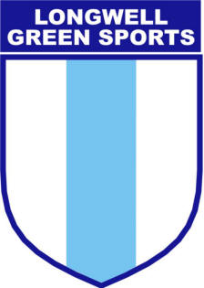

Respect Code of Conduct for Spectators and Parents/Carers
We all have a responsibility to promote high standards of behaviour in the game. This club is supporting The FA’s Respect programme to ensure football can be enjoyed in a safe, positive environment. Remember children’s football is a time for them to develop their technical, physical, tactical and social skills. Winning isn’t everything.

Play your part and support The FA’s Code of Respect:

I will:

- Remember that children play for FUN
- Celebrate effort and good play from both sides
- Respect the rights, dignity and worth of each and every player
- Always respect the Referee and coaches and encourage players to do the same
- When players make mistakes, offer them encouragement to try again next time
- Never engage in, or tolerate offensive, insulting or abusive language or behaviour
- Remain outside the field of play and within the Designated Spectators’ Area (where provided)

I understand that if I do not follow the Code, I may be:

- Issued with a verbal warning
- Obliged to leave the match venue by the club
- Required to meet with the Club Committee, Principle or County FA Welfare Officer
- Obliged to undertake an FA education course
- Requested by the club not to attend future games
- Suspended or have my club membership removed
- Required to leave the club along with any dependents and/or issued a fine

Formed 1966

